

CoFFEA Delivery

A DC-Based Coffee Delivery Business



January 10, 2021

IBM Coursera Capstone

Madeline Kushan

Table of Contents

|  |  |
| --- | --- |
| **Topic** | **Page Number** |
| Introduction | 2 |
| Data | 3 |
| Methods | 6 |
| Results | 7 |
| Discussion |  |
| Conclusion |  |

This report explores the best business strategy for a new coffee delivery service based in Washington, DC.

**Introduction**

Background

Washington, DC is the capital of the United States and is home to a wide range of museums and restaurants. Despite its many tourist attractions and exciting venues, DC locals tend to work intense, demanding jobs with long hours. A [2015 Washington Times article](https://www.washingtontimes.com/news/2015/mar/19/dc-residents-have-third-longest-workweek-including/#:~:text=Despite%20the%20critiques%20that%20no,commuting%20to%20and%20from%20work.) notes that DC residents have the third-longest workweek in the nation, averaging 48 hours and 39 minutes weekly. Long hours and grueling commutes make caffeine an essential component to most DC residents' workdays.

A recent [DCRefined](http://dcrefined.com/eat-drink/feel-the-buzz-dc-ranked-in-top-10-best-coffee-cities-in-america" \t "_blank) article reveals that DC ranked first in average ranking of coffee shops on The Daily Mail's "50 Best Coffee Shops" list, sixth in average spending on coffee per household, and 10th in the Top 20 cities for Coffee Lovers. These stats indicate that coffee is a well-loved beverage in the capital.

Problem Description

Young entrepreneur Coffea is interested in starting a coffee delivery business in DC. With COVID forcing most individuals to work from home, coffee businesses are suffering and coffee drinkers are missing their favorite coffee venues. While major food delivery services like UberEats, DoorDash, and GrubHub can deliver coffee, Coffea's business would be optimized for coffee delivery. Optimization would include the following:

1. Equipment to keep hot coffee hot and iced coffee cold
2. Partnerships with local coffee venues
3. Efficient delivery system to provide coffee services

Coffea wants to determine the best homebase for her company to ensure its success. In order to determine where to focus her efforts she must consider the following questions:

1. Which DC neighborhoods have coffee shops as their top venues?
2. Which DC neighborhoods are the wealthiest and most likely to use Coffea's service?

Target Audience

The target audience for this project is the business owner Coffea as she seeks to determine the best coffee-shop partnerships and home-base for her coffee-delivery business. The business would benefit both DC coffee shops and DC coffee-lovers.

Anticipated Success

Since DC residents seem to love coffee more than the average American, coffee-based services should be successful. Especially during the pandemic, a coffee-delivery service could support small businesses and allow DC residents to enjoy their favorite coffee shops remotely. These factors suggest that a coffee delivery service based in a affluent, coffee-loving area would be successful.

**Data**

Data Requirements

To determine the best location for Coffea's Coffee Delivery business, we need to consider the following data:

1. The geographical coordinates of DC neighborhoods
2. Which DC neighborhoods have coffee shops as their most popular venues
3. Which DC neighborhoods with popular coffee shops have the highest rent

Data Collection

The data for this project comes from a few main sources. Firstly, geopy was used to obtain geographical coordinates of DC neighborhoods displayed in Figure 1. Using folium, each neighborhood can be plotted on a map as shown in Figure 2.

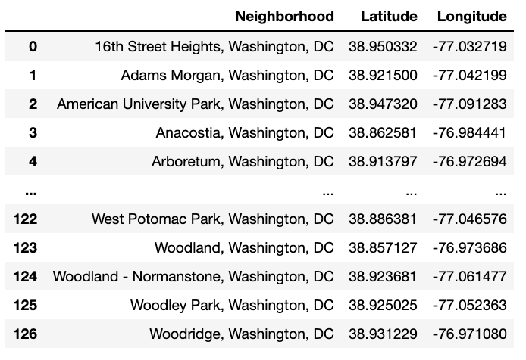

Figure 1. Coordinates of DC Neighborhoods

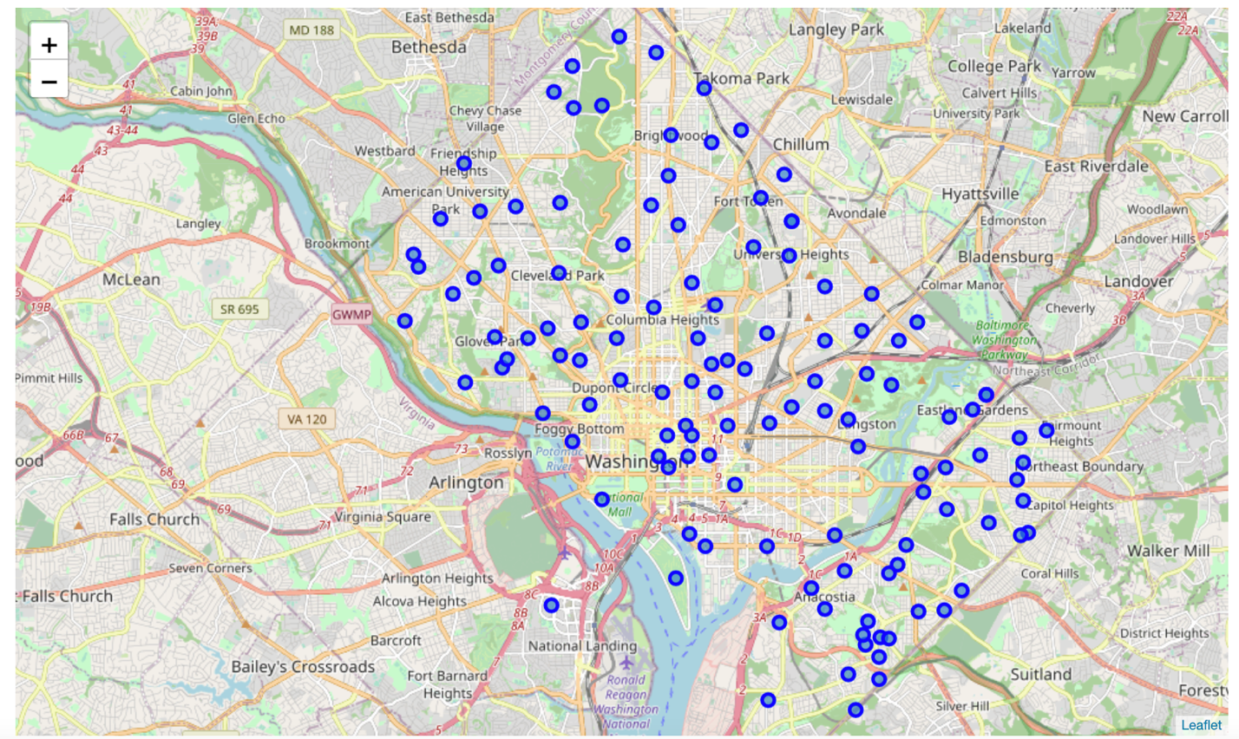

Figure 2. Map of Washington, DC with Neighborhoods in blue.

FourSquare was used to obtain information about popular venues in each neighborhood. These could then be narrowed to neighborhoods with coffee shops as their most popular venues. This information allowed us to isolate 16 neighborhoods in DC which included coffee shops as their most popular venues (Fig 3).

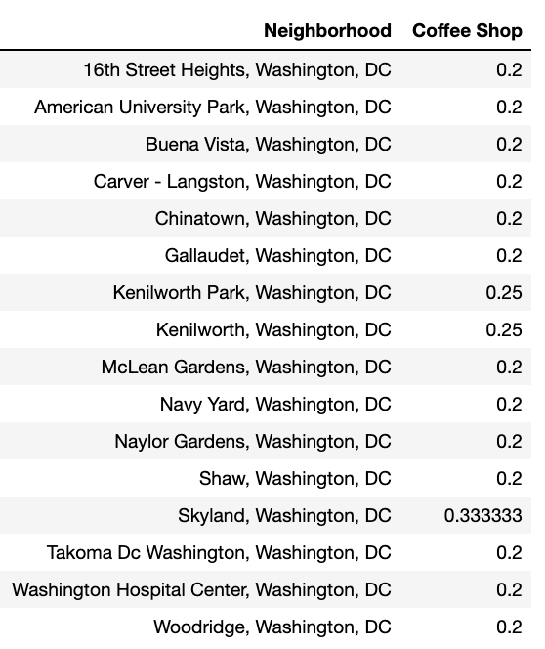

Figure 3. Neighborhoods in DC with coffee shops listed as their top venues on FourSquare.

Since Coffea is a new company, it is wise to have its core in an affluent area which would be more likely to take advantage of its services. Average rent in each neighborhood was used to determine affluence. Average Rent in each neighborhood was obtained by scraping [RentCafe's data on DC rent](https://www.rentcafe.com/average-rent-market-trends/us/dc/washington/" \t "_blank). This data produced Figure 4.

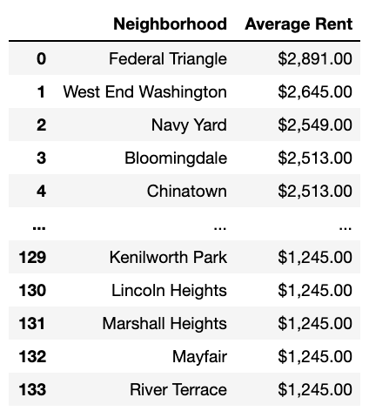

Figure 4. Average Rent in DC by Neighborhood from RentCafe.

**Methodology**

Exploratory Analysis

Data scraping was used to extract useful data from various sources and combine it in a meaningful way. The BeautifulSoup library was used to pull data from html files on rent and coordinates. Data was then organized using Pandas to obtain dataframes that could be more easily assessed. First, the rent data and coffee shop neighborhoods were combined and plotted to produce Figure 5. K-means clustering was used and mapped using geopy and folium. These analyses offer insight into where Coffea should begin its business and how it might expand over time.

**Results**

The results of the analysis highlight affluent neighborhoods which likely have a high volume of coffee-lovers based on the popularity of coffee-shops in the neighborhood. Figure 5 visualizes this using average rent in the 16 neighborhoods which FourSquare revealed as listing coffee shops as their top venues.

K-means clustering helped us to separate three clusters which could be used to organize delivery in the future and provide a plan for expansion over time. Figure 6 displays the 16 coffee-neighborhoods in their respective clusters.

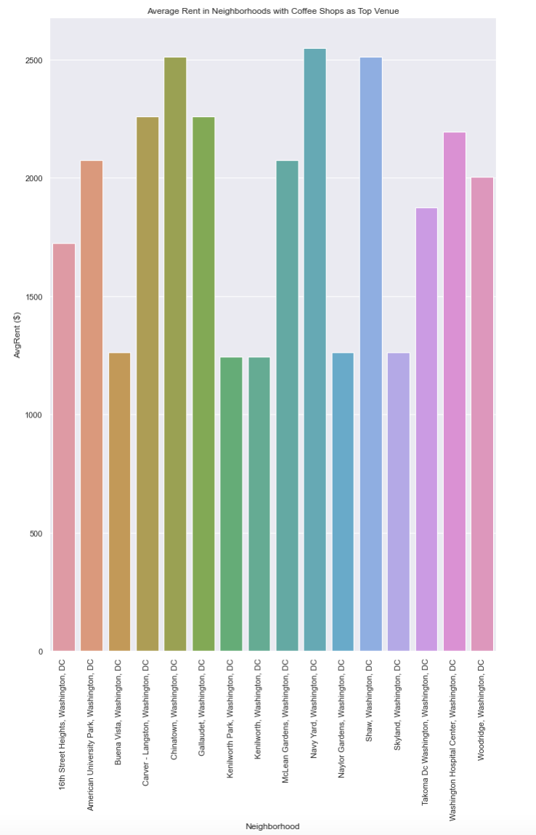

Figure 5. Average Rent in DC Neighborhoods with Coffee Shops as most Popular Venue.

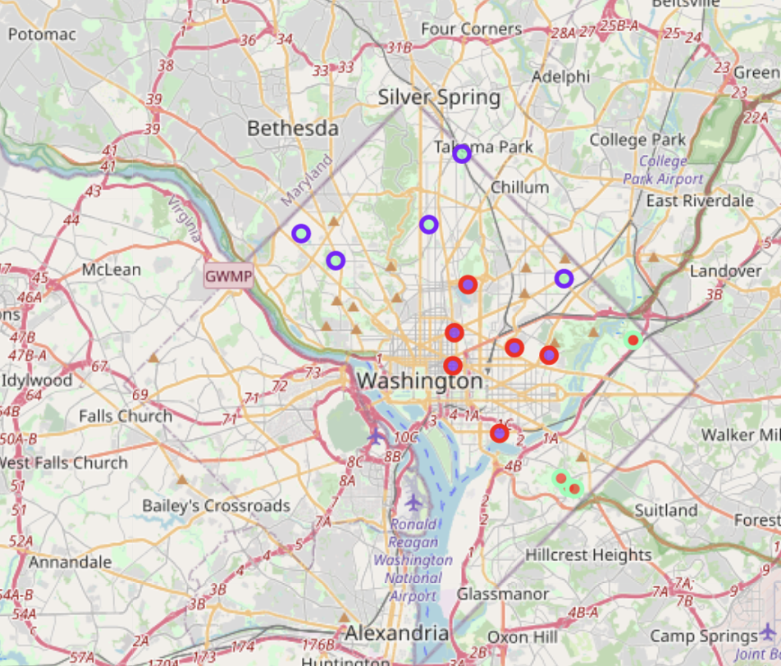

Figure 6. Neighborhoods with Coffee Shops as top venues clustered using KMeans Clustering.

**Discussion**

Coffea coffee delivery seeks to partner with coffee shops in DC to deliver coffee to resident coffee lovers. To optimize success as it begins, Coffea to begin its network in neighborhoods that list coffee shops as top venues. Additionally, Coffea would likely appeal to people who are willing to spend more money for the convience of coffee delivery and the quality of their favorite coffee shop’s coffee. To target this audience, we have isolated neighborhoods with high rent.

Targeting neighborhoods with higher rent would likely improve the probable success of Coffea Coffee delivery, so Navy Yard, Shaw, and Chinatown could be good Neighborhoods to focus on first (Fig. 5). The K-means clustering provides three main clusters which could each provide a home-base for Coffea as it expands to serve the entirety of DC.

**Conclusion**

With small businesses suffering more than ever during quarantine, delivery services could alleviate some of the strains on local coffee shops. DC is known for being full of coffee-lovers and overworked employees, making it a perfect location for Coffea’s new coffee delivery business. This project seeks to help Coffea determine where to start her business so that it will be well-received and successful. We determined the two factors to consider to be popularity of coffee-shops in a neighborhood and affluence of the neighborhood. Based on these factors, Coffea should seek partnerships with coffee shops in Navy Yard, Shaw, and Chinatown first. If her business proves successful, she can use the three clusters provided in figure 6 as a reference to expand her business, relying on coffee-loving neighborhoods as her hubs.